**CONTENT OF THE EMISSIONS DATA COMMUNICATION TEMPLATE**

**Emission data communication from operators Information on embedded emissions may be provided by operators to reporting declarants using an ‘emissions data communication’ template report, which has been developed by the European Commissions and which is given in Annex IV of the Implementing Regulation (Regulation (EU) 2023/1773).**

The use of this template is not obligatory but can greatly facilitate the information exchange.

The template is divided into two parts: the first part of the template contains all necessary embedded emissions information that you, as the reporting declarant, need to compile for your CBAM report; the second part of the template is an optional section that operators are recommended to complete, as it will provide greater transparency of the data reported under Part 1.

Reporting declarants may use the information in Part 2 to carry out their own data quality checks on the contents of Part 1.

The contents of the operator’s emissions communication is outlined in the table below for your information.

*Table: Contents of the operator’s emissions data communication to reporting declarants*

|  |  |
| --- | --- |
| **Template** | **Summary of information required for the transitional period** |
| **Part 1 General information** | **Includes the data to be communicated to the reporting declarant.**   * Installation data, comprising identification and location details for the operator’s installation, and contact details for the operator’s authorised representative. * The production processes and routes under each aggregated goods category at the installation. * For each aggregated goods category or separately for each good by CN code: * The direct and indirect specific embedded emissions of each good; and for SEE indirect detail on how the emission factor was determined and the information source used; * Information on what data quality and methods (calculation based, measurement-based, other) were used for determining embedded emissions, and whether this was based fully on monitoring, or if default values were used; * Information on the correct amount of electricity consumed (expressed in MWh/unit of goods); * If default values were used, a short description why these were used instead of actual data; * Information on additional sector-specific reporting parameters for goods produced, if required; and * If applicable, information on a carbon price due, and separately for any precursors obtained from other installations, by the precursors’ country of origin. |
| **Part 2 Optional information** | **Provides greater transparency of the data under Part 1, and allows the reporting declarant to carry out validation checks on Part 1.**   * The total emissions of the installation, including: activity data and calculation factors for each source stream used; emissions of each emission source monitored using a measurement-based methodology, and emissions determined by other methods; and if applicable, any CO2 imports or exports to other installations, for the reasons outlined above. * A ‘heat balance’ of imported, produced, consumed and exported measurable heat, and similarly balances for waste gases or electricity. * A list of all relevant goods by CN code produced by the installation, including precursors not covered by separate production processes. * For precursor goods:   + The quantity received from elsewhere.   + Their specific direct and indirect embedded emissions (as reported by other operators).   + The quantity used in each production process, excluding precursor goods produced in the same installation.   + For attributed direct and indirect emissions: information on how the attributed emissions of each production process were calculated; the activity level and attributed emissions of each production process.   + A short description of the installation, covering: relevant and nonrelevant (out of scope) production processes; * The main production processes taking place at the installation and any production processes not covered for CBAM purposes;   + The main elements of the monitoring methodology being used; and   + What measures to improve data quality have been taken, in particular whether any form of verification (in the definitive period) was applied. * Information on the electricity emissions factor in the power purchase agreement, where appropriate. |

To help operators share their information on embedded emissions with you, as a reporting declarant, the template in Annex IV has been translated into a ‘voluntary to use’ spreadsheet, providing the information under Parts 1 and 2 in the table above. The following Figure shows how this spreadsheet template is structured.

Figure: Voluntary electronic data communication template – Contents page



Key features of the template include:

• User-friendly navigation and automatic calculation of CBAM embedded emissions data from data inputs, showing how attributed emissions have been calculated for each production process.

• Covers information for both Parts 1 and 2 in the operators’ report above, identifies what data is required for the reporting declarants to complete the CBAM report and what data is optional, and provides guidance on how to use the template and on the different calculations performed.

• Tools for facilitating reporting, for attributing emissions between heat and electricity for CHP/cogeneration and for calculating the carbon price due.

• Summary sheets providing the main information on production processes and products to be communicated to the reporting declarant for their CBAM Reports. The spreadsheet is available from the European Commission’s dedicated website for the CBAM.

The spreadsheet is available from the European Commission’s dedicated website for the CBAM.

The spreadsheet and an example of completion are available on the European Commission’s dedicated website for the CBAM and can be accessed at the following link:

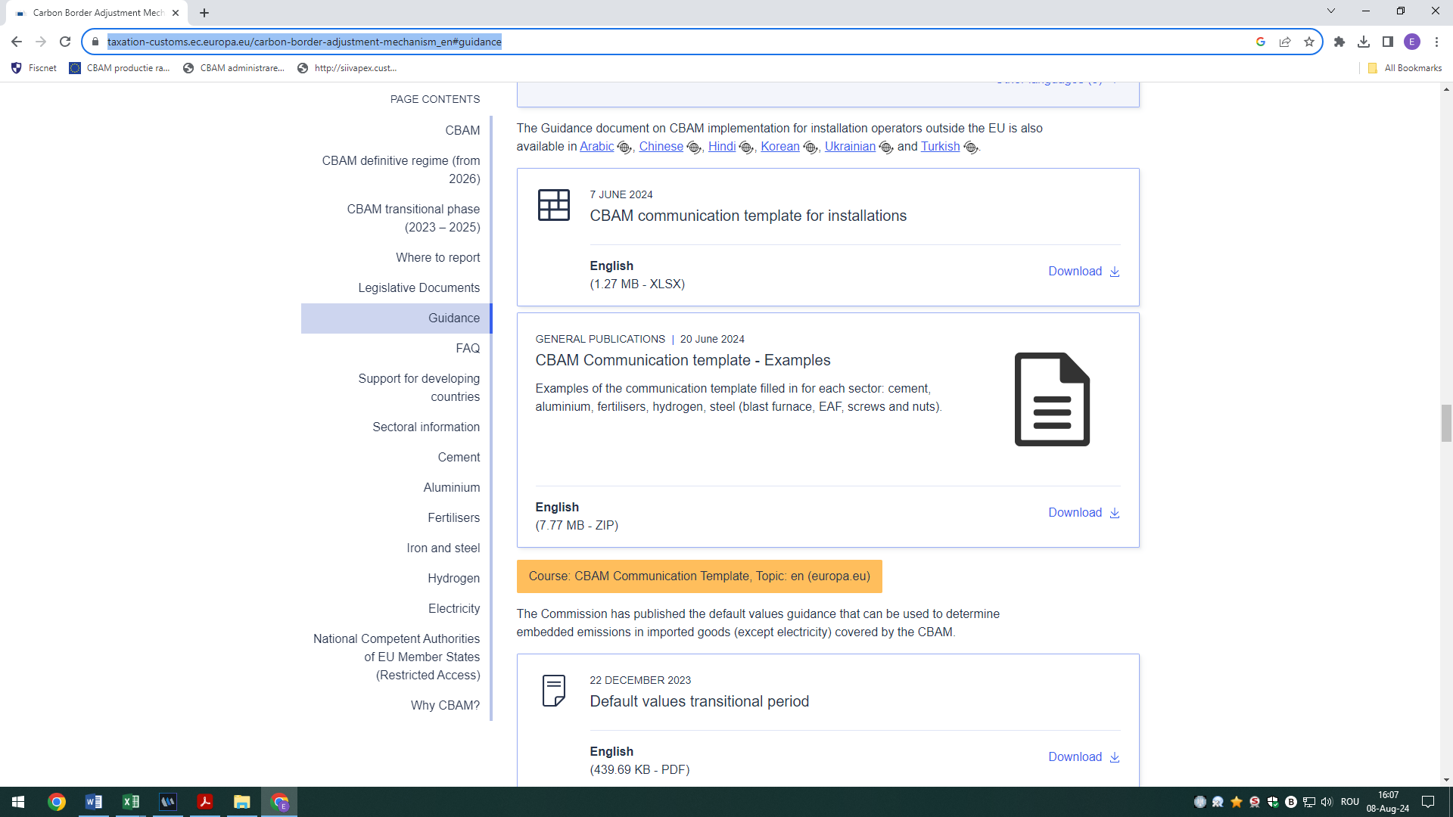[https://taxation-customs.ec.europa.eu/carbon-border-adjustment-mechanism_en#guidance](https://taxation-customs.ec.europa.eu/carbon-border-adjustment-mechanism_en" \l "guidance)